Requirements

What is (are) the repository URL(s)?
What is (are) the repository URL(s)?

GitHub

In the example Excel file:

In the code:
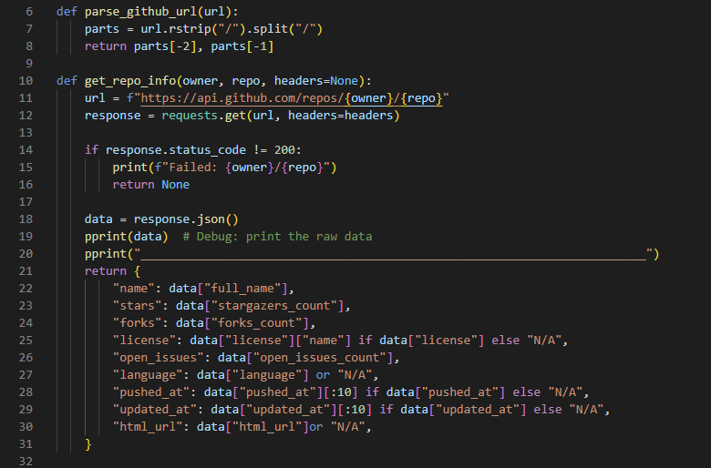

Pre-processing and Pipeline Code

Code Documentation Quality
What level of documentation does exist for the code?

README EXISTS

In the example Excel File:
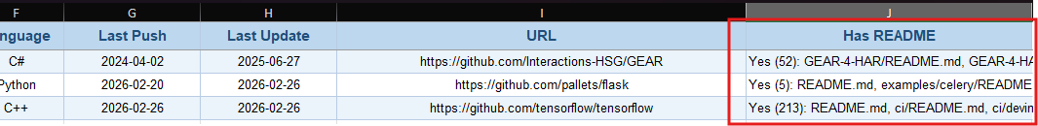

In the code:
